# **WEEK 4**

*1# Write a java program to check whether the given number is odd or even.*

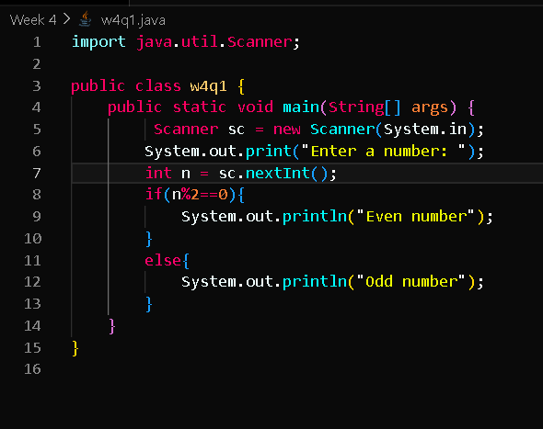

**Output:**

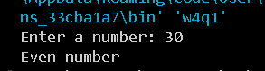

*2# Write a java program to find the largest number among the three numbers.*

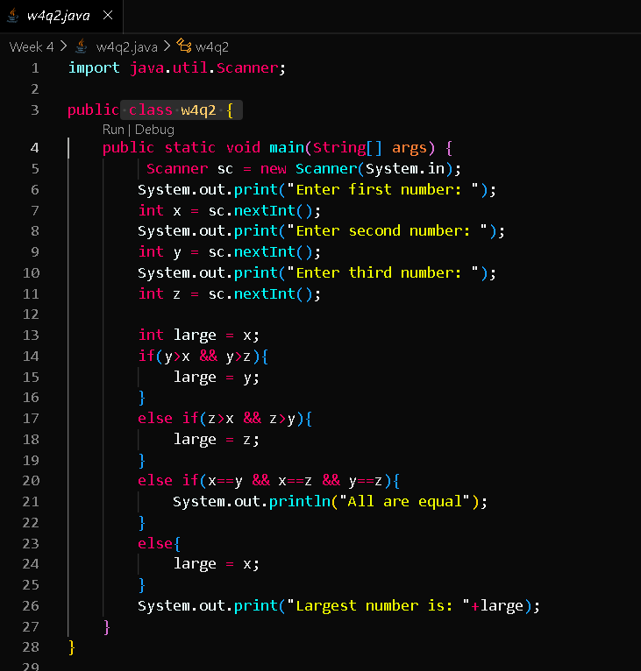

**Output:**

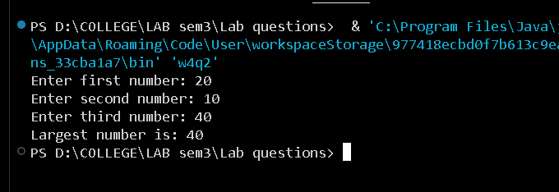

*3# Write a Java program that takes a number as input and prints its multiplication table up to 10.*

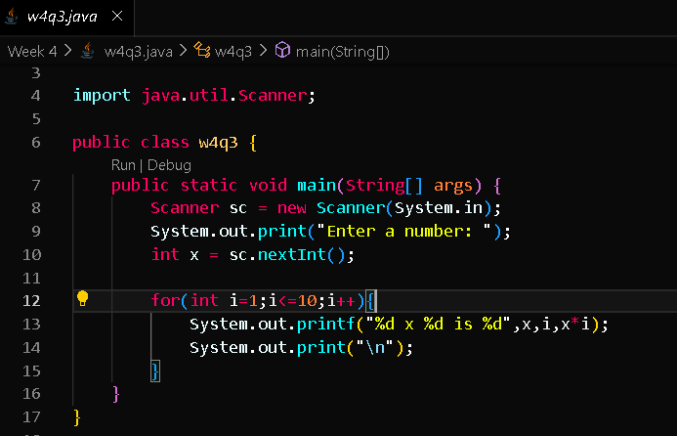

**Output:**

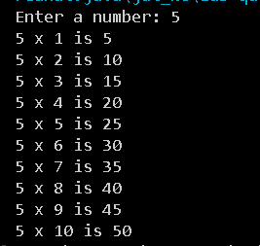

*4# Write a Java program to calculate the sum of following series: 1 + 2 + 3 + 4 + .......... + N*

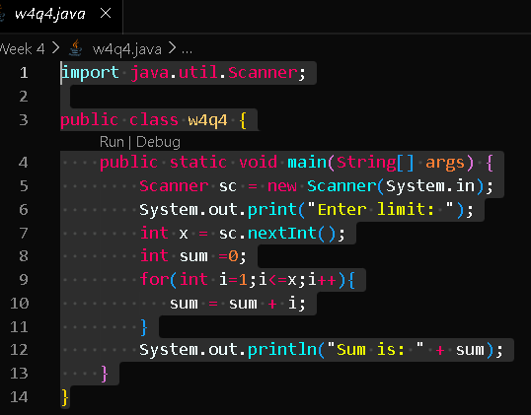

**Output:**

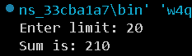

*5# Write a Java program to take a number, divide it by 2 and print the result until the number becomes less than 10.*

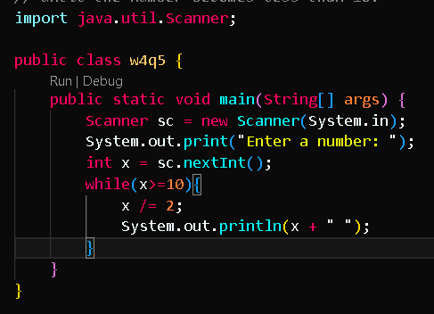

**Output:**

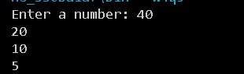

*6# Write a Java program to check whether a given character is a vowel or consonant.*

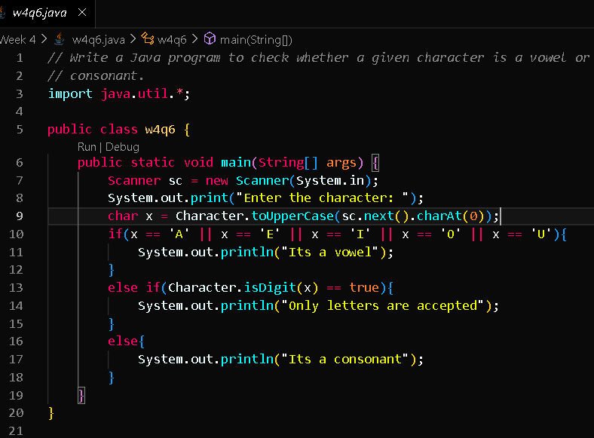

**Output:**

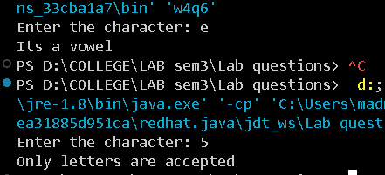

*7# Write a Java program to find the smallest number among four given numbers.*

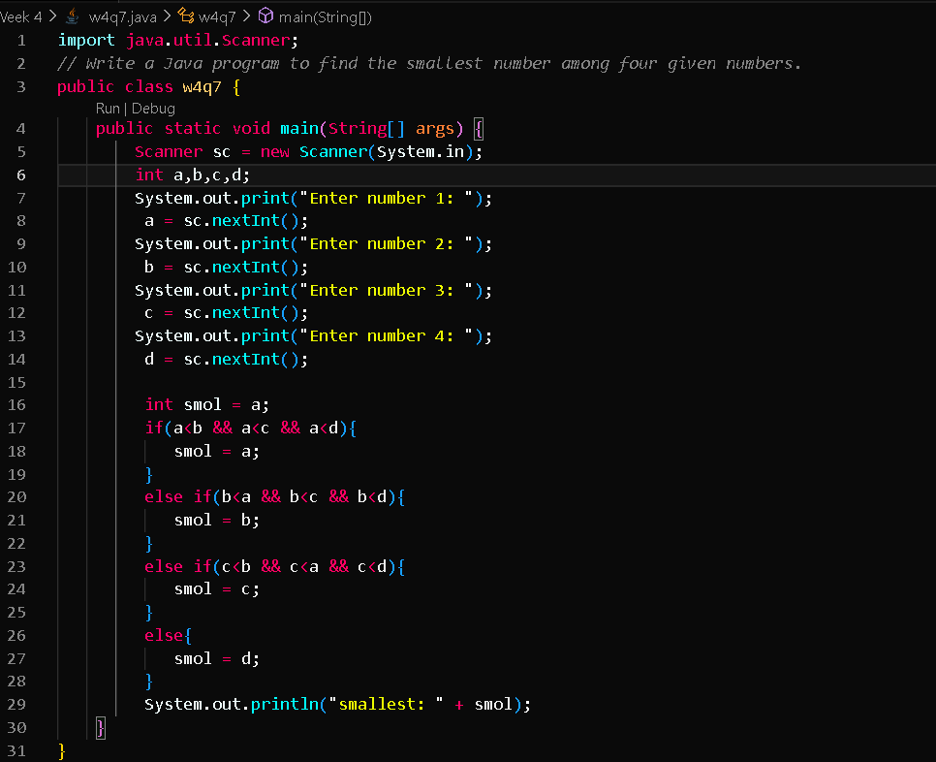

**Output:**

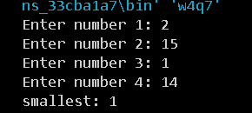

*8# Write a Java program to calculate the sum of all even numbers from 1 up to a given number N.*

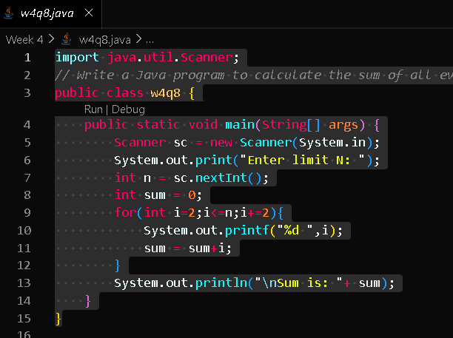

**Output:**



*9# Write a Java program to check whether a given year is a leap year or not.*

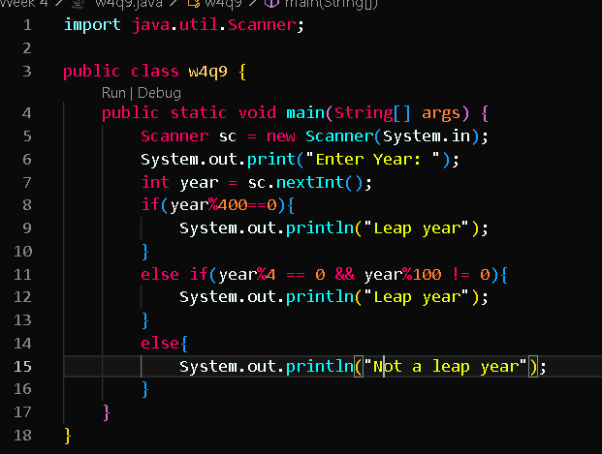

**Output:**



*10# Write a Java program that takes a number as input and prints all its factors.*

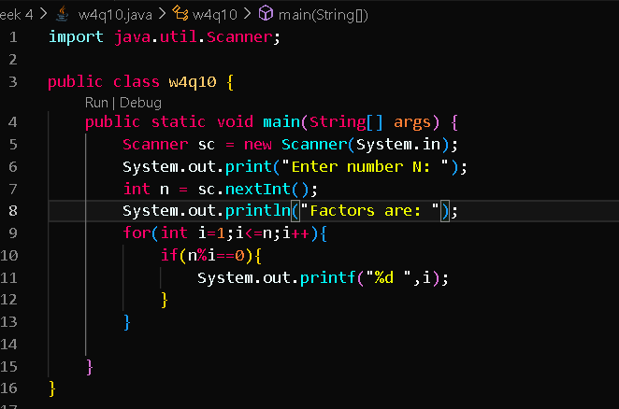

**Output:**

